**Frontex trained 250 experts from Western Balkans and Turkey**

2019-05-17

On 16 May, Frontex together with representatives of the European Asylum Support Office (EASO), International Organization for Migration (IOM), the office of the UN High Commissioner for Refugees (UNHCR) and other local partners in Belgrade, Serbia, discussed the achievements of the first phase of the EU-funded “Regional Support to Protection-Sensitive Migration Management in the Western Balkans and Turkey” project.

The aim of the project was to introduce and share EU standards and best practices on migration management in the Western Balkan region and Turkey.

Frontex and its partners supported the countries in developing a protection-sensitive response to migration flows, assisting them in strengthening systems that aim at better identification and referral of those migrants that are in need of international protection or asylum.

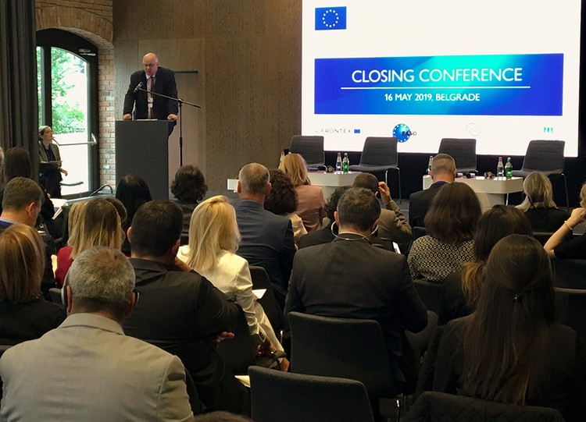

In the course of the project, Frontex organised more than 20 training sessions for 250 participants from the Western Balkans and Turkey. The topics ranged from combatting trafficking in human beings to the detection of document fraud and the respect for fundamental rights during return operations.

 “The project allows us to respond effectively to common challenges in the EU and in our neighbourhood. Border guards need to be able to identify vulnerable groups. This is why Frontex helps strengthen the identification, registration and referral systems in the beneficiary countries,” said Frontex Deputy Director during his speech in Belgrade.

A part of Frontex’s efforts also concentrated on return operations, a core part of the EU migration management policy. To ensure that the highest standards, including fundamental rights, are respected during return operations, the agency’s experts provided a range of training activities for the beneficiary countries, helping them develop an operational and transparent return system based on a unified European approach and procedures.

The project was organised in the framework of the Instrument for Pre-Accession Assistance (IPA II) to six Western Balkan countries and Turkey. The participants renewed their commitment to support the region’s countries in migration management and will start work on the kick-off of the second phase of the project today.